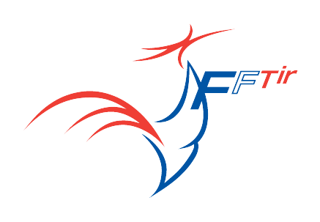
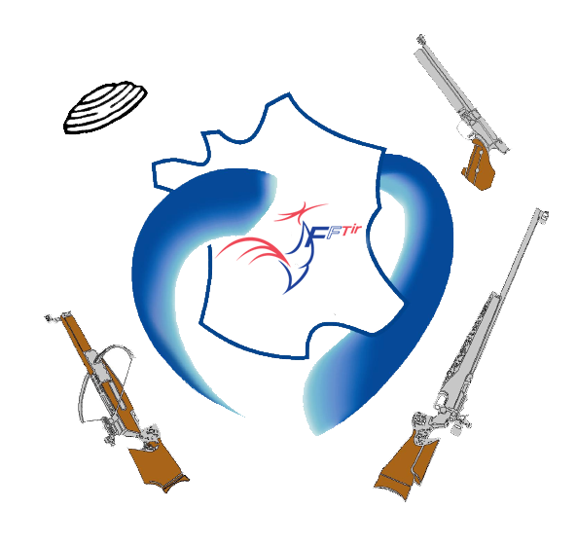

TRAVEL INFORMATIONS

The Organizing Committee will provide transportation for all delegations from the local arrival place to the assigned hotels in arrival day and back on departure day, and from the hotels to and from the shooting range.
Shuttles available beetwen hotels and shooting range are free.

For the delegations that will arrive in Paris, a bus service to reach Fleury will be provided (for go and return). It will be charged 30 €/person.

ARRIVAL INFORMATION |  |  |  |  | DEPARTURE INFORMATION
AIRPORT | RAIL | BUS | CAR |  | AIRPORT | RAIL |  | BUS | CAR
DATE |  |  |  |  | DATE
TIME |  |  |  |  | TIME
ARRIVAL PLACE |  | Airport  Railway station |  |  | DEPARTURE PLACE |  |  | Airport  Railway station
Nb of PERSONS |  |  |  |  | Nb of PERSONS
YES |  | NO | Arrival & Departure transfert requiered? |  |  |  | YES |  |  | NO
YES NO |  |  | Local transfer is required ? |  |  |  | YES NO
Time from Paris to Fleury by bus : nearly 2 hours.

